Lets make copy of an array by normal method

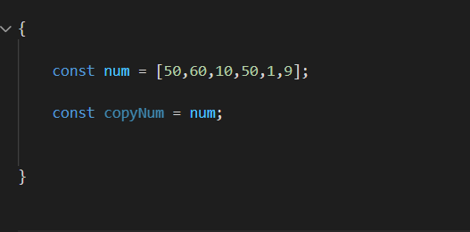

Here what happens is both num and copyNum points to the same memory address

So if we change copyNum, Num also gets changed

And this could be a problem

In above let say we need both original array and also an array with items arranged in ascending order

So

We use

**.slice( ) method to copy array with separate memory address**

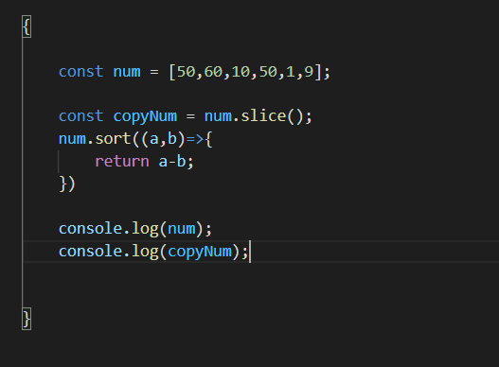

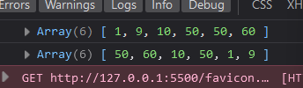

Finding highest and lowest item out of the elements in the array

